**FPT International School**

--- o0o ---

**PROJECT REPORT**

**<Insurance>**

Batch: T2303E

Semester: HKI

Group: 4 Glasses Guys

Member :Nguyễn Văn Lưu -TH2302034

Nguyễn Hữu Nghĩa -TH2302010

Nguyễn Hữu Hoàng Viên -TH2302026

**Hanoi - 08/2023**

**Table of Contents**

1. Problem Definition 3

i. Introduction 3

ii. Implementation Environment 3

User Stories 4

1.2 User type 1 4

i. Story 1 4

ii. Story 2 4

iii. Story 3 4

1.3 User type 2 4

i. Story 1 4

ii. Story 2 4

2. Database 5

2.1 DB Relationship Diagram 5

2.2 Table 1 (company) 5

2.3 Table 2 (product) 6

2.4 Table 3 ( Product_detail) 6

2.5 Table4(contact) 6

3. UI\UX 7

3.1 GUI 1 (Homepage) 7

3.2 GUI 2 (Product) 7

3.3 GUI 3 (Search) 8

3.4 GUI 4 (Contact) 8

3.5 GUI 5 (Register form) 9

4. Summary 10

# Problem Definition

### Introduction

The insurance always important in my life .

However, the work schedule is busy, the location is far away, and there is no convenient means of transportation time slots pose as major barriers when applying concepts to realism. And so it is necessary to look for alternative means of performance in ladder approach. The above really place special restrictions on our students! With their busyness schedule, is really difficult for our students to keep up with genuine and. The constant need for integrated applications can be seen directly, especially in IT education field where technology can change rapidly.

technology will help us at such times!!

### Implementation Environment

Code storage : Git - hub

Front - End : HTML, CSS, EJS

Backed - End : EXPRESS, NodeJS, Javacripts, My SQL server.User Stories

## User type 1

i. Customer can go in the website and will be welcome by a homepage that is divided into sections with a search bar and information to catch user’s attention.

ii. Users can browse through insurance plans categorized by the type of vehicle they're driving, or they can simply choose a or select available insurance plans.

iii. After choosing a plan , they can see detailed information and what they need to pay attention to when signing up . After registering they can see additional support and terms to pay attention to after registration

## User type 2

**i.** Student users will be greeted by the homepage and can use the search bar to quickly find what they are looking for

ii. From there they can quickly view information after searching .

# Database

## DB Relationship Diagram

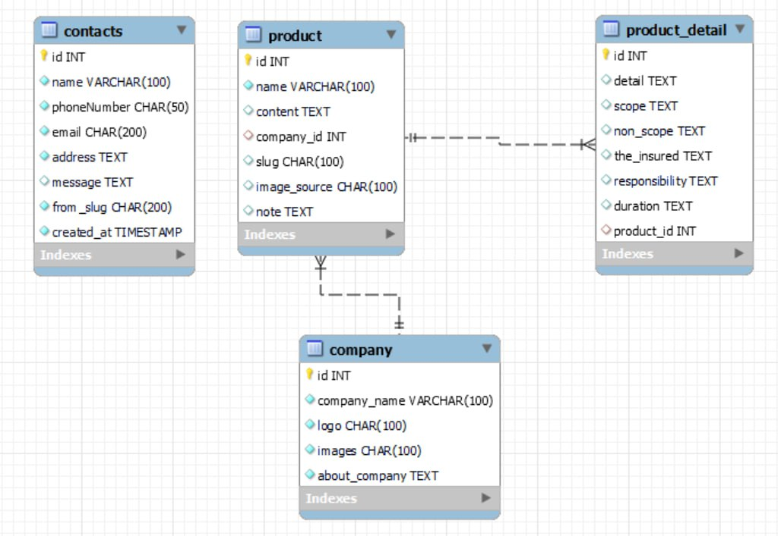

## Table 1 ( Company)

|  |  |  |  |
| --- | --- | --- | --- |
| **Column Name** | **Data Type** | **Constraint** | **Description** |
| id | INT | PK | Primary key of the table |
| Company_name | Varchar(100) | Not null | Status of the company |
| Logo | Char(100) | Not null | Logo |
| Image | Char(100) | Not null | Image |
| About_company | Text | Not null | About_company |
|  |  |  |  |

## Table 2 (Product)

|  |  |  |  |
| --- | --- | --- | --- |
| **Column Name** | **Data Type** | **Constraint** | **Description** |
| Id | int | PK | Primary key of the table |
| name | Varchar(100) | Not null | Name product |
| content | Text | Not null | content |
| Company_id | Int | FK | Foreign key of the table |
| Slug | Char(100) | Not null | Path to page |
| Image_source | Char(100) | Not null | Image |
| note | text | Not null | note |

## Table 3(Product_detail)

|  |  |  |  |
| --- | --- | --- | --- |
| **Column Name** | **Data Type** | **Constraint** | **Description** |
| Id | INT | PK | Primary key of the table |
| detail | Text | Not null | Status of the product |
| scope | Text | Not null | Scope in the product |
| non_scope | Text | Not null | Non-Scope in the product |
| The_insured | Text | Not null | The insured |
| responsibility | Text | Not null | responsibility |
| duration | Text | Not null | Enjoyment time |
| Product_id | INT | FK | Foreign key ò the table |
| created_at |  |  |  |
|  |  |  |  |

## Table4(Contact)

|  |  |  |  |
| --- | --- | --- | --- |
| **Column Name** | **Data Type** | **Constraint** | **Description** |
| Id | Int | PK | Primary key of the table |
| name | Varchar(100) | Not null | name |
| phoneNumber | Char(50) | Not null | phoneNumber |
| email | Char(200) | Not null | email |
| address | Text | Not null | address |
| messenger | Text | Not null | messenger |
| from_slug | Char(200) | Not null | from_slug |
| Product_id | timestamp | Not null | create_at |

## 

# UI\UX

## GUI 1 (Homepage)

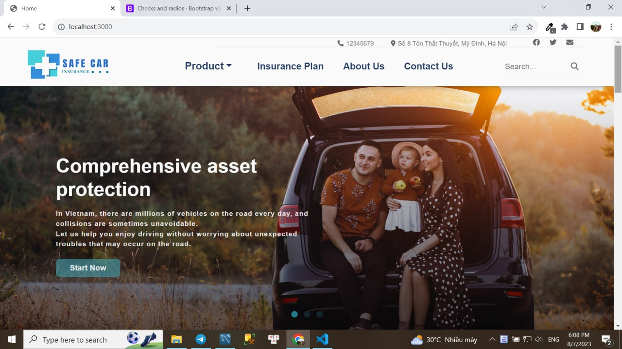

## GUI 2 (Product)

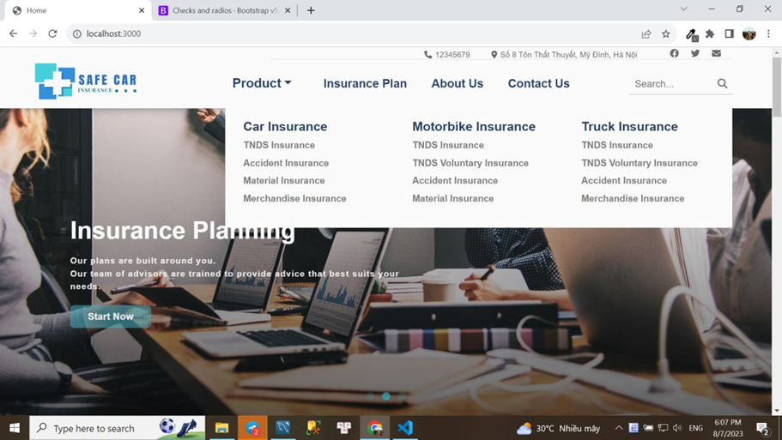

## GUI 3(Search)

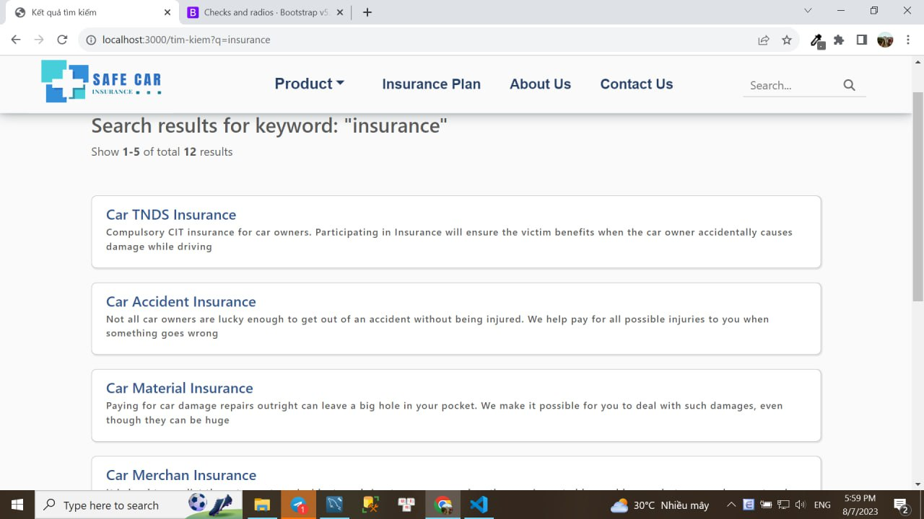

## GUI4(Contact)

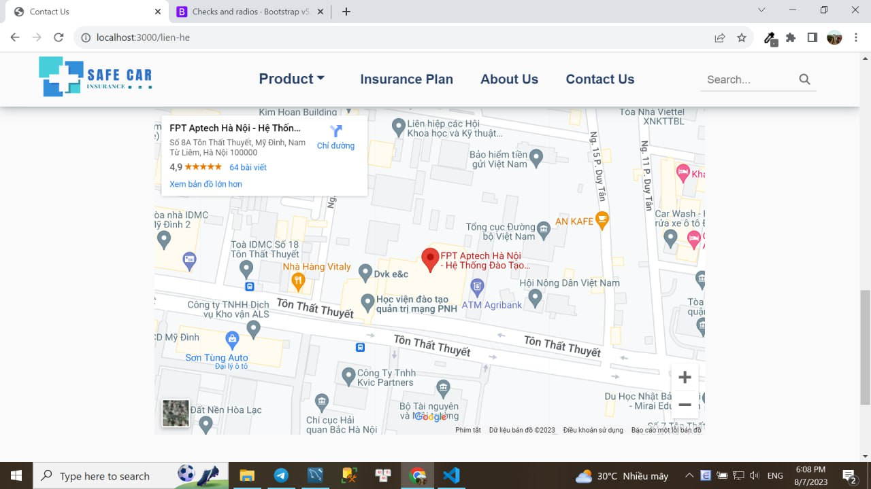

## Gui5(Register form)

## 

## 

## insertDb of register form

## 

## Validation of register form

## 

# Summary

However, the work schedule is busy, the location is far away, and there is no convenient means of transportation time slots pose as major barriers when applying concepts to

realism. And so it is necessary to look for alternative means of performance in

ladder approach.

The above really place special restrictions on our students! With their business

scheule, is really difficult for our students to keep up with genuine and

The constant need for integrated applications can be seen directly, especially in

IT education field where technology can change rapidly.

technology will help us at such times!!

Personal summary:

Throughout this project, I have learnt the skills to create a website that is good to look at, to put myself in the shoe of a customer/client who with or without a purpose access the website looking for information or just simple browse. Using those skills, with the usage of HTML, NodeJS, EJS, Express, CSS, JS and framework other . I have created a website that can catch the attention of the viewer and provide all the necessary tools for the user to navigate throughout the page looking for the information they need and make it very simple for them to be able to contact the website management company. I have also learnt a lot of things about how a relational database work as well as the workflow and communication between front-end side of things and back-end side of things. There is a thing that I can improve on that is team work, communication between teammates and get a better understanding of the team to divide work flow better and help everyone synchronize to work together and utilize git and git-hub to futher improve the efficiency of the team as member and a leader. **- Lưu**